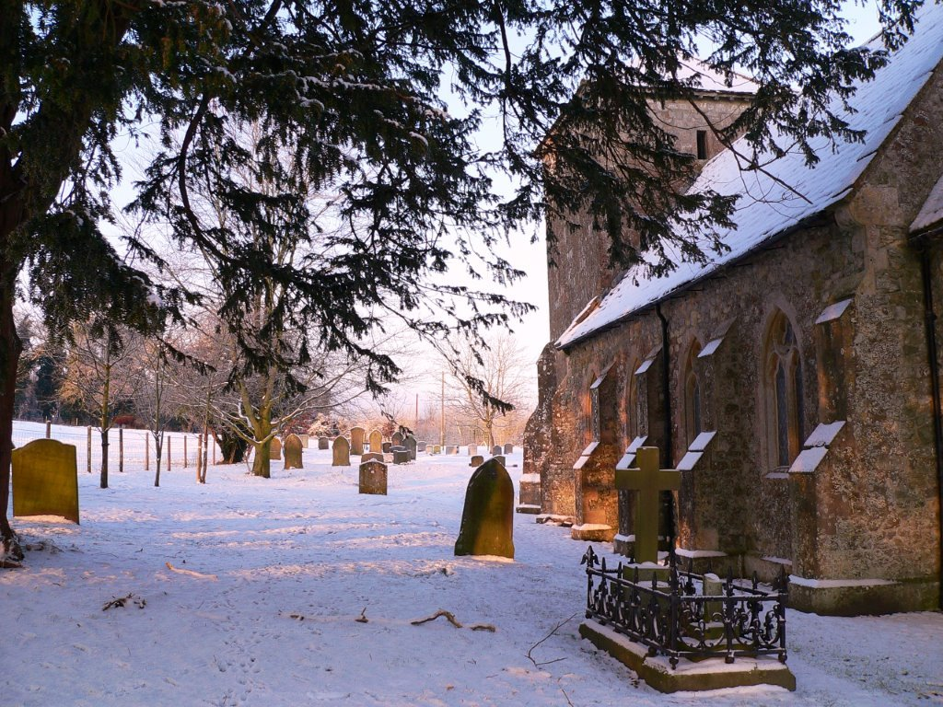  The windows in the church were restored in 2002 to 2004 to commemorate the Millennium and the Queen’s Golden Jubilee. The windows endowed are marked by a lozenge with the initials of the donor, date and cross keys of St Peter. The project was executed by Mr Andrew Turner, a creator of stained glass and expert glazier of Littleton Panell.  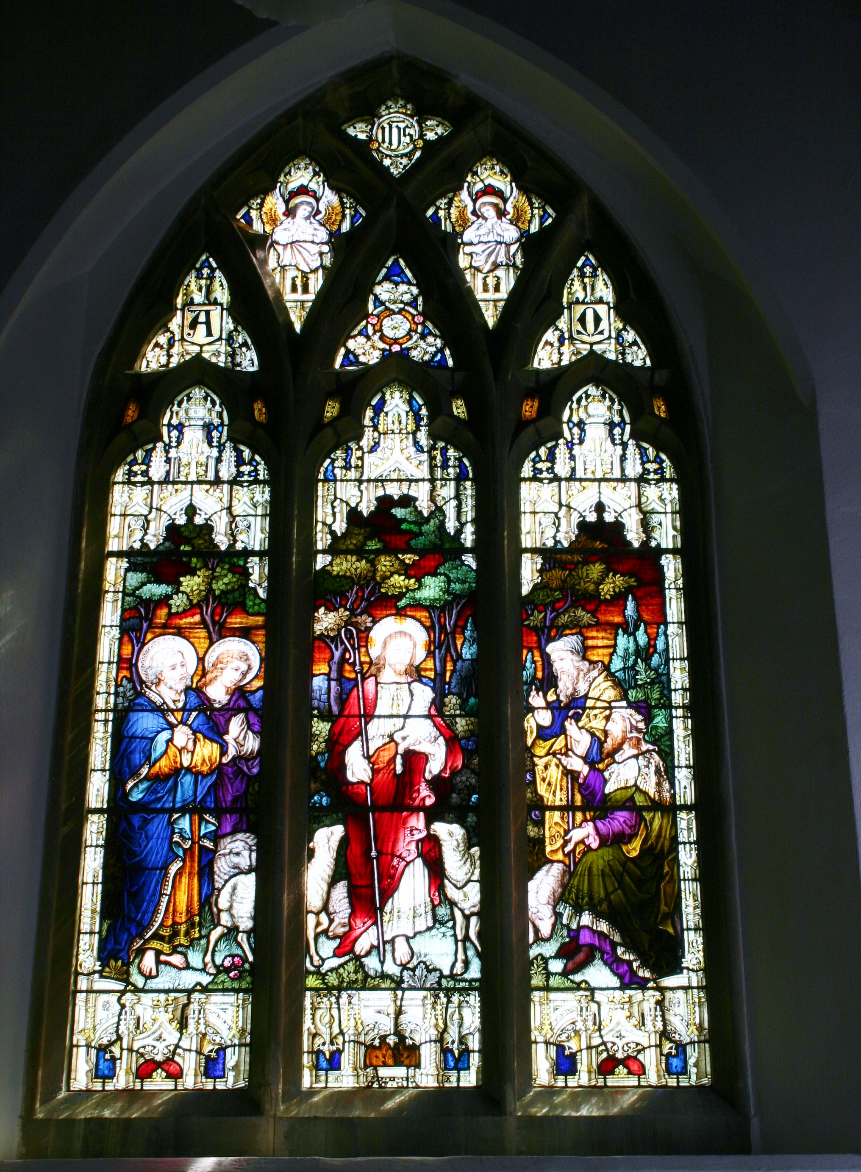
  St Peter’s Church,
  Little
  Cheverell
  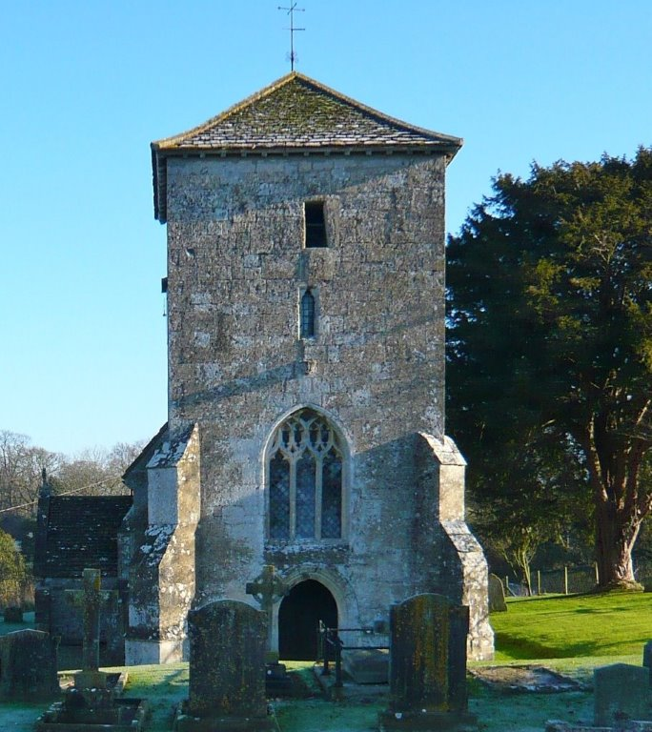
  A Short History

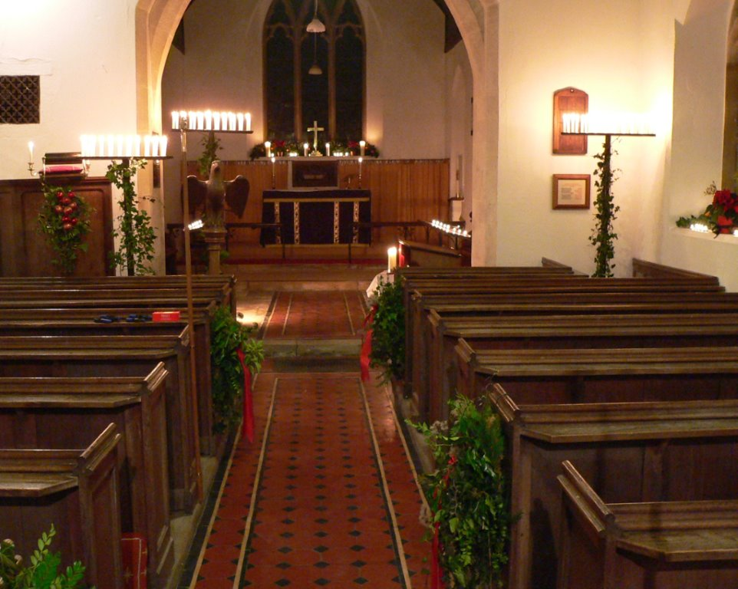
The work of beautifying this little church has been continued through the centuries. People from Little Cheverell being generous, thoughtful and skillful in their generosity.
In 1980 84 hassocks were remade and recovered, each one made by someone with a real interest in our church, linking the lives of parishioners with those who have gone ahead in at least seven centuries of Christian presence in Little Cheverell.

In 2005 the roof, which had deteriorated to such an extent that it leaked badly, particularly in the chancel, underwent major repair and refurbishment. The cost, which exceeded £30,000, being met through the generosity of many people in the village, by no means all regular members of the congregation of St Peter’s, as well as a number of charitable trusts, local businesses and so on.

  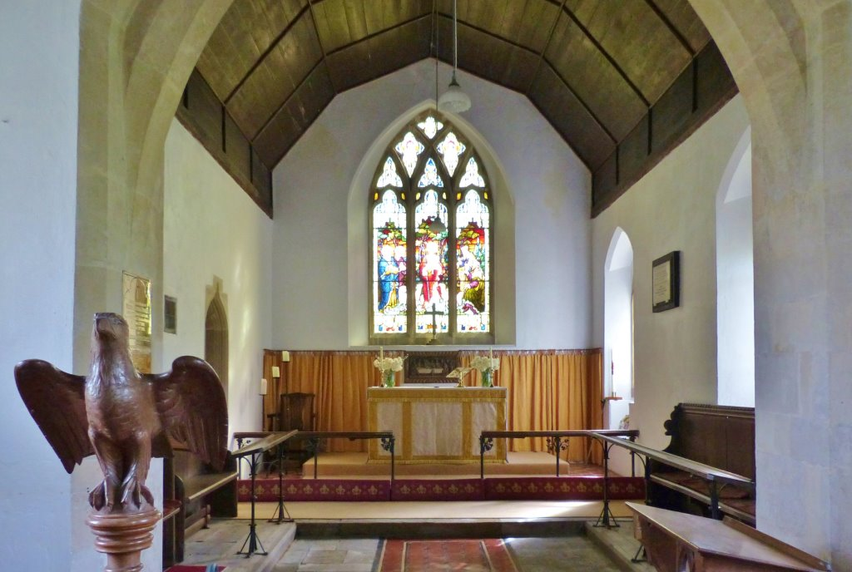
  Notes for visitors to the church
  It is known that there has been a church on this site since the 12th century.
  In records of 1332 and 1534 it is referred to as St Nicholas Church, becoming St Peter’s sometime in the 1850s.
  Architects have told us that there are traces of Saxon work still remaining in the tower.
  The main parts of the present church were rebuilt to designs of Thomas Cundy in 1850. The work was done by Messers Bilton and Sainsbury of West Lavington at the cost of £500. The opening morning and evening services were attended by no less than 15 clergy.
  The tower with its 15th century west window the porch and the priest’s doorway that has been built between the vestry and the chancel all survive from the earlier, smaller church.
  There was a chantry chapel standing in 1298 to the north of the church, the foundations of which were uncovered in 1832, but nothing of this is now visible.

Items of Interest
There are two 18th century memorials high up on the inner tower walls.
Hanging in the bell-chamber are two early 14th Century bells, probably cast in Salisbury, which are still in use. The clock strikes the hours on one of these bells.
The clock itself is only about (100/150) years old, being a replacement for one mentioned as being old and needing repair in 1760.
The coat of arms on the wall above the font is that of William IV (1830—1837).
The chalice and paten in regular use were given to the church in 1661.
The carved reredos was given by a rector early twentieth century.
A converted chamber organ replaced an harmonium shortly after the First World War and originally stood just inside the chancel on the North side.
Restored once in 1982, it was completely rebuilt and installed in its present location by the organ builder Stephen Cook in 2006.

