TOP TEN TREES
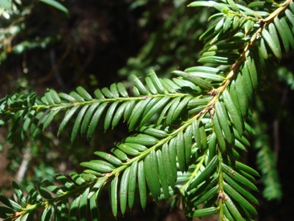  Yew | 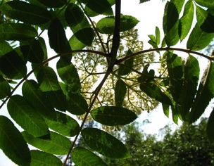  This Photo by Unknown Author is licensed under CC BY  Rowan
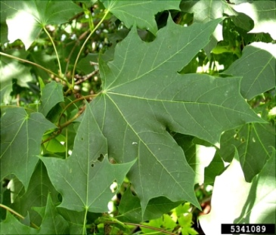  This Photo by Unknown Author is licensed under CC BY  Maple | 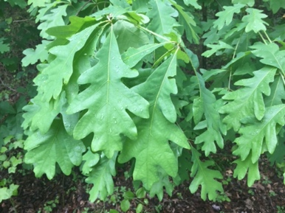  Oak
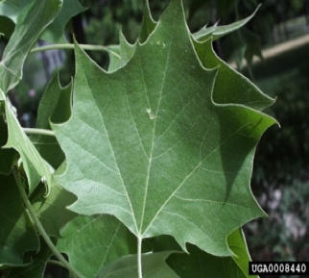  This Photo by Unknown Author is licensed under CC BY-NC  Sycamore | 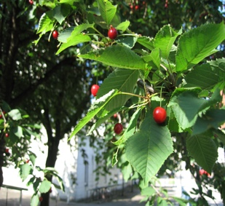  This Photo by Unknown Author is licensed under CC BY  Cherry
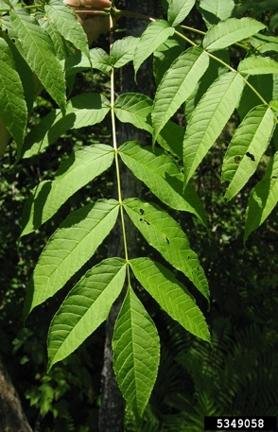  Ash | 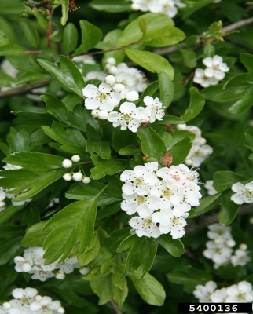  Hawthorn
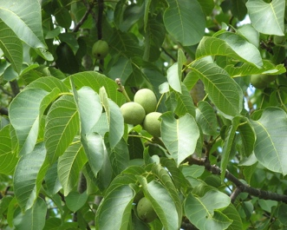  This Photo by Unknown Author is licensed under CC BY-NC-ND  Walnut | 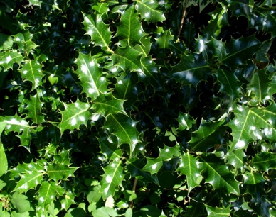  Holly

